Intro :

It is common in the educational process that parents want their children to have their academic level and grades in continuous development and in this research the writer used data mining using methods in data mining using binary classification approach , the author has chosen decision tree and decision tree more accurate than neural network .

in research the author use data warehouse technique and get data from two sources , first from the journal and second from jakarta and tangerange city and total data 425 data , consists of 425 data and 395 from first source and 30 from data in second source in city ,

Rapid Miner is a program licensed under the GNU Affero General Public License version

3[14]. This program has a convenient interface,

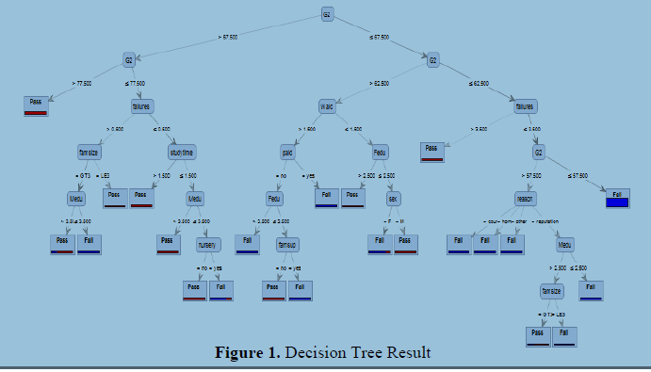

Result :

If the value of G2 is greater than 67.5, then in next branch it will be checked again, if G2 is greater than 77.5, then certainly the student will pass on the next test. If not, then the next check is whether failures (experiencing failure) is greater than 0.5 or not.

In other words, whether the student has experienced failure or never experienced it, because

the input received is only in integers 0.1,2,3,4.

If the student has experienced a failure, then the next attribute, famsize (number of family

members) will be examined. If famsize is a GT3 (Greater than 3 / more than 3), then Medu

will be checked next (Mother's last education) if it is greater than 3.5 or in other words is 4

which means passing college, then the student is predicted to pass. If the mother's last

education is below college graduation, then the student is predicted to fail or fail on the next

test. Next, back to 2 node level above, if the famsize is LE3 (Less equal 3 / below or equal to

3 people) then the student is predicted to pass.

Back to third level node from the top, if the student has never experienced a failure at all,

then study time will be checked (out-of-school time). If the study time attribute of the student

is more than 1.5 (at least studying with a minimum duration of 2 hours), then the student is

predicted to graduate. However, if less than 1.5, then check the value of Medu, if Medu value

is above 3.5 (at least must pass college), then the student is predicted to pass. If the Medu

value is below or equal to 3.5, then the next attribute that will be checked is nursery (never

entered nursery). If the value is a yes, then the student is predicted to fail, and if the value is a

no, then the student is predicted to pass.

Then return to the top level node, if the value of G2 is smaller than or equal to 67.5, then

G2 will be re-checked, whether G2 is greater than 62.5. If G2 is greater than 62.5, then the

next attribute to be examined is Walc (the level of alcohol consumption at the weekend),

whether it exceeds the level of 1.5 or not. If it exceeds the level 1.5, then the next attribute we

check is paid (does the child attend a paid course outside school?).

If the child is attending a paid course class, the child is predicted to fail, but if not then the

Fedu attribute (Father's last education) will be examined. If Fedu has value more than 3.5 (at

least graduated from college), then the child is predicted to fail, if the Fedu value is smaller or

equal to 3.5, then check the famsup attribute (additional education by parent), if there is

additional education from the parents, This child is predicted to fail, but otherwise, if this

student does not get additional education from parents at home, then this child is predicted to

pass.

Conclusion :

from 33 attributes and 425 rows of data which use them in study , it turns out that 12 of attributes really effect on result and achievements .

upper secondary students. Those 12 attributes are sex, Medu, Fedu, famsize, reason,

studytime, failures, famsup, paid, nursery, walc, and g2. 2nd year exam score (G2) is the most

influential attribute compared to all other attributes. Both parents' education also has an

important role to play in their children's achievement in school. Then failures (number of

failures) also have an important effect. Learning from failures proves to play an important role

in a child's achievement. Alcohol consumption also has a great effect on achievement. For

other attributes, such as famsup, paid, nursery, sex, famsize, little effect on student

achievement because of its position in the tree that are in the bottom of the root.